**Filing of Form DIR-3KYC/DIR-3KYC-Web/ACTIVE without any filing fee**

The Ministry of Corporate Affairs (MCA) has come up with the ‘Companies Fresh Start Scheme 2020’ to enable companies make good of any filing-related defaults, irrespective of duration of default, and make a fresh start as a fully compliant entity.

MCA in furtherance to its Circular no. 11/2020 dated 24th March, 2020, vide its Circular no. 12/2020 dated 30th March, 2020, in the wake of COVID 19, has introduced the “Companies Fresh Start Scheme, 2020” to provide an opportunity to make good any filing related defaults, irrespective of duration of default, and make a **fresh start** as a fully compliant entity.

Further to this the Ministry of Corporate Affairs has announced in News and Important Updates section (Screenshot of the same is given below) on its website [**http://www.mca.gov.in/**](http://www.mca.gov.in/) that “*DIN holders of DINs marked as ‘Deactivated’ due to non-filing of DIR-3KYC/DIR-3 KYC-Web and those Companies whose compliance status has been marked as “ACTIVE non-compliant” due to non-filing of Active Company Tagging Identities and Verification(ACTIVE) eform are encouraged to become compliant once again in pursuance of the General Circular No. 11 dated 24th March, 2020 & General Circular No.12 dated 30th March 2020 and file DIR-3KYC/DIR-3KYC-Web/ACTIVE as the case may be between 1st April, 2020 to 30th September, 2020 without any filing fee of INR 5000/INR 10000 respectively.*”

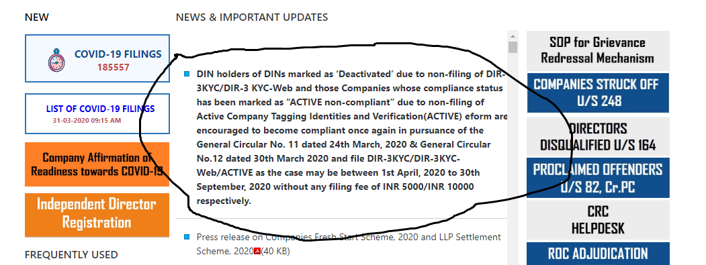

**This means that there is no need to pay any additional fees file DIR-3KYC/DIR-3KYC-Web/ACTIVE between 1st April, 2020 to 30th September, 2020.**

**Mayank Arora & Co.**

**Company Secretaries**

Add: Office no. 268, 2nd Floor,

Udyog Bhavan, Sonawala Road,

Goregaon (East), Mumbai - 400 063.

**M: +91-9324254455**

**L: 022-49735566**

**Website:** [**www.mayankarora.co.in**](http://www.mayankarora.co.in)



Date: 31st March, 2020